The author of this document and thousands
of seriously ill people would encourage you to click the images below,
Thank you.

The IMP

General Information

- Introduction

- Overview. ... Is it a spreadsheet or is it an app?

- System Requirements ... Will it run on my computer?

- Using IMP for the first time ... Learn the basics before you start.

- Future Development. ... It’s a constant work in progress.

- Password and VBA access ... Getting under the hood

- Acknowledgements ... With apologies to unknown heroes

- Screen Shots. ... Images of a working IMP.

1 - Introduction
The IMP is a tool that allows you to quickly and conveniently record, update and control your stocks and shares portfolio. IMP is a simple basic tool designed specifically for small non professional investors. It's not a stock picker. It won’t tell you what to buy or when to sell and for how much. It does not do historical data or technical analysts. All that stuff is freely available out there for those that need it.
A typical user of the IMP might be someone who leaves all that to technical stuff and the leg work that goes with to experts such as those at Motley Fool.
However when eventually you make your purchases and investments what the IMP will do is keep track of them and their ever changing values.
The role of an IMP is to act as a book keeper, an organiser, keeping things up to date and so help you take control of your investments and assets.
You can create up to 25 portfolios or sector groups and IMP can show you the results of each one separately as well as the combined value of them all. So you could have one portfolio for yourself and another for your partner. IMP would then show you your combined wealth or you could view each one separately. If you have just one portfolio in your IMP you could divide it up into 25 separate groups or sectors and because your total wealth probably involves more than just stock and shares, it’s flexible too.
You're probably worth more than the sum of your shares.
Although IMP was primarily designed to monitor stocks and shares, It is just as capable of recording any asset that has a value. Some assets such as property come with a cost and can soon become a liability if you don't keep on top of it. Each entry in your IMP comes with a basic accounts page where you can record income as it's generated such as dividend payments, interest or rent as well as expenses incurred such as fees, tax or the cost of that central heating system. So whether it's cash in the bank, property or your collection of classic cars, if it has a value and needs managing, IMP is the tool to use.
It's packed with time saving features designed to help you control your finances and make life easier.
For example once you have told IMP where you live then no matter where you buy your shares, IMP will display the results in your home currency using the latest exchange rates.
So take your time getting to know your new IMP and how to use it because once you do you’ll never want to be without it.

2 - Overview
Is it a spreadsheet or is it an app? The answer is both. But unlike most spreadsheets the app element takes priority. So don’t be alarmed if when you open your IMP for the first time it looks nothing like your typical spreadsheet.
Excel is the engine that powers the IMP but all you see and use is the IMP itself.
In normal use there is no need to know anything about the engine or how it works.
It’s a bit like your car. You don’t need to know what’s going on under the hood in order to use it.
Let’s continue with that analogy for a moment. Suppose you do know a thing or two about engines and you wanted your car to not only get you from A to B but also have a winch or to act as a generator of electricity or even both. If you have the knowhow then why not go for it. If you don’t know how the engine works or how to get it to do other stuff then you’ll just have to use it as the manufacturer designed it.
In the case of the IMP the engine or excel is accessible to anyone, you just have to look under the hood. Then you can tinker about with it to your hearts content. Just make sure that what you end up with is something that everyone can still use. Not something that only other excel mechanics will know how to use.
Any app or program is just a collection of bits of code put together in such a way so as to do the job in hand. It’s then wrapped in a user friendly interface, one that anyone can use and then given a name. In this case we call it the IMP. Without that interface it would be called a spreadsheet.

3 - System Requirements
The IMP will work any computer running Microsoft’s Windows 7 or higher and using Microsoft Office (Excel) 2007 or higher in 32 bit configuration.
Feedback has shown that although it makes no difference whether your computer has a 32 or 64 bit operating system, if your Office suite or Excel has been set to 64 bit, IMP will have compatibility issues with the VBA.
Sadly we do not as yet have a 64 bit Office version available..

4 - Using IMP for the first time
The first time you open your IMP you are greeted by a series of framed panels. These panels are designed to offer help and guidance as you make your way through the initial start up process.
There are just two things you need to do before you can enter your first investment.. The first is optional but in many cases it will be necessary and that is to adjust the viewable area IMP takes up on your screen.
The second is a requirement in that you must tell IMP what country you live in.
With this information IMP can indentify your foreign investments. Then, using the latest exchange rates, it can calculate and display the results for those investments in your home currency. Pretty neat huh?
Its worth taking a bit of time getting to know your IMP in this way before you dive in and make your first entry, as once you have made your first entry these panels will no longer be displayed but you will always have the user guide to refer too.
Familiarising yourself now with how your IMP works and reading the help manual will save you a lot of time and frustration latter on.

5 - Future Development
The IMP as you fined it today is by no means the finished article and that is true no matter when you are reading this. The coding behind it has been described as lumpy and no doubt it would make your average professional programmer cringe.
Originally written by a self taught armature and announced to the world on the
13th of October 2014 the first version went by the name the_imp_v1-21
The hope was that because of its open source design, anyone willing and able would be free to get inside, correct errors, make improvements and suggest modifications.
The aim being that one day the IMP might become a slick “professional” looking tool that could be considered a finished product, but in truth that day is unlikely to arrive.
That original hope continues and is as true today as it was back then. As long as there are generous people out there prepared to give of their time and knowledge for the benefit of others, the IMP will always be in a consent state of work in progress.
To be considered a true IMP, appearance and what it does will always take priority over how it does it. See the overview section for more on this philosophy.

6 - Getting under the hood.

The following is information that you may find of interest or even necessary should you want to examine your IMP’s internal working. Once again you are advised to make a copy of your IMP before attempting any of these procedures.
~
To unprotect the currently selected worksheet only, use the password 555.
To re-protect the sheet using the same password just click any of IMP’s navigation buttons.
~
To unprotect and unhide all hidden rows and columns of the currently selected worksheet only, run the macro named AA_Open_Activesheet
To reinstate the worksheet to its previous unopened and protected condition, navigate your way to the Home page, if you’re not already there, click the Current Holding button and then click the small imp logo below the green arrow of the investment scroll button.
~
To unprotect and unhide all hidden sheets, rows and columns of all the sheets in your IMP,
run the macro named AAA_Unhide_All_Columns. ... (See Note 1 below)
To reinstate your IMP to its previous unopened and protected condition, navigate your way to the Home page, if you’re not already there, click the Current Holding button and then click the small imp logo below the green arrow of the investment sheet scroll button.
~
Access to the VBA code is via the password, CliveForemanVolvop1800 (case sensitive)
~
Note 1
The AAA_Unhide_All_Columns macro will not in fact open or unprotect the Info2 sheet.
Use the AA_Open_Activesheet macro to archive this but remember to select it first.
Note 2
Use this information with caution as it could kill your IMP... and if you do that you’ll be getting a visit from our gnomes department.

7 - Acknowledgements
As previously stated the IMP is made up of bits of code, VBA code to be precise.
Much of what makes the IMP tick comes from snippets of code published on the internet either in the form of help reference sites or individuals who have generously donated them for public consumption.
Over the years I amassed a collection of these code samples although at the time most of them were complete gobbledegook to me. Eventual I taught myself enough knowledge to realise how they could help me solve the problem of keeping my portfolio up to date and from this came the idea of the IMP.
Unfortunately and to my shame I did not keep any records of where these code samples came from. Never the less these unsung heroes deserve to be acknowledged for their efforts. My plea therefore is that if you should recognise any of the code within the IMP, no matter how heavily modified, please contact me and I will dually add their name to a list of contributors here on this page.

I cannot believe that I wrote the above statement without reference to the great ANC1.
Without his or her skill, knowledge and above all generosity in making the GetData code publicly available, the IMP and many other personal portfolios would not exist today.
I came across the link that first brought me to this wonderful piece of work and for those who are interested in the history of such things I supply it below.
http://boards.fool.co.uk/freebie-share-prices-in-excel-fast-and-easy-10845944.aspx
8 - Screen Shots ... page 1 Taken from version v2-0-0
This is the first image you see when you open an IMP for the first time. It has been included in order to prepare those expecting to see a more traditional looking spreadsheet.
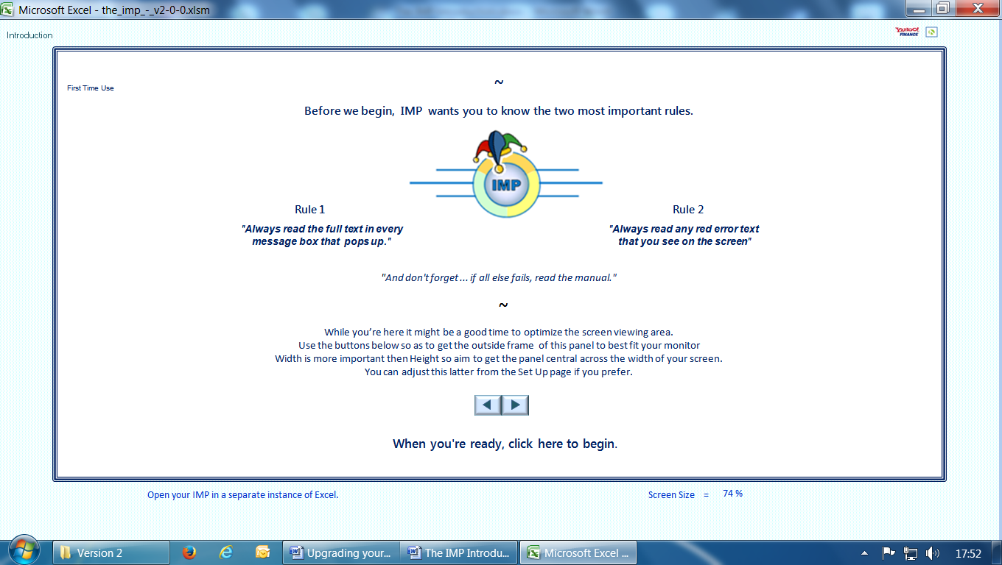
Just two clicks latter and you will arrive at the Home page, Current Holding view. This is the default view of the Home page and is the one you will return to whenever you click the Home button from any investment sheet.
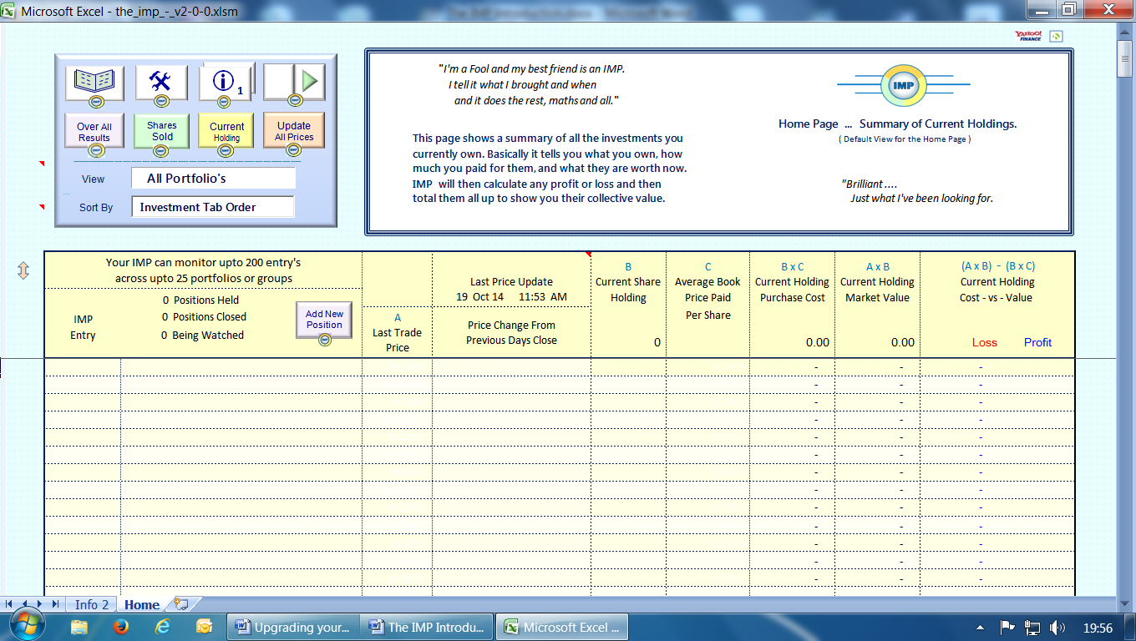

Screen Shots ... page 2 Taken from version v1-21
As you’re IMP is devoid of any entries you well be guided to the Set Up page.
Here you must chose your home country from the drop down list. Once that’s done you can return to the Current Holding view and begin the process of adding your first investment entry.
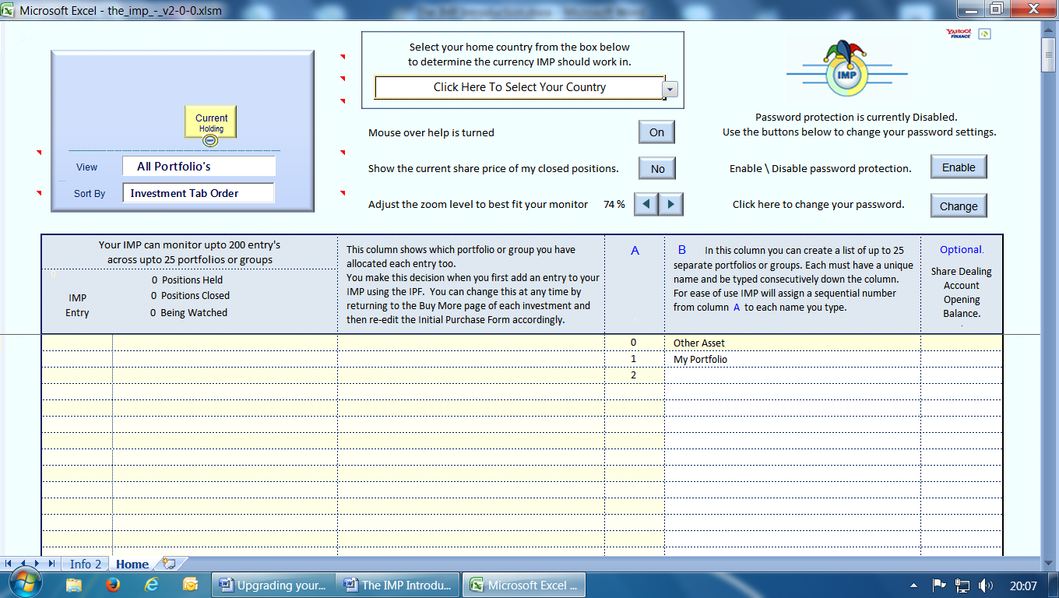
Adding an entry involves filling out the Initial Purchase Form. Once that is complete any subsequent top up purchases are then entered in the Buy More section.
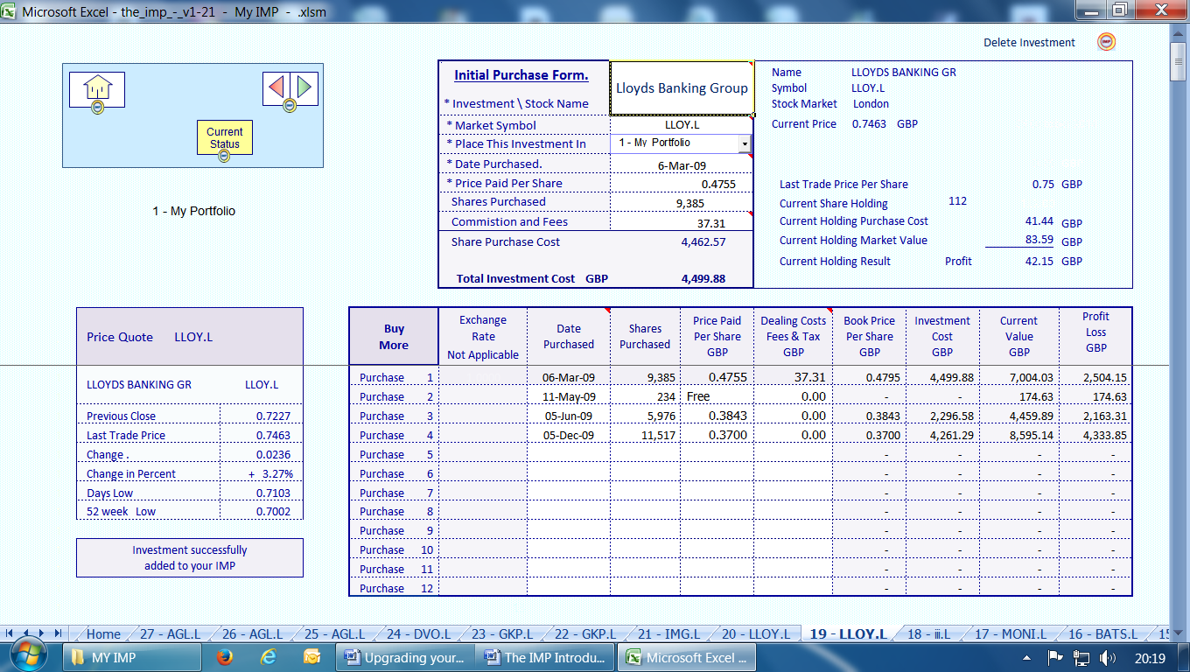
Screen Shots ... page 3 Taken from version v1-21
Entering records of sales transaction is done by filling the Sales Card and just like the Buy More section there are only four elements to it. It’s an IMP rule that you can only enter data into white coloured cells
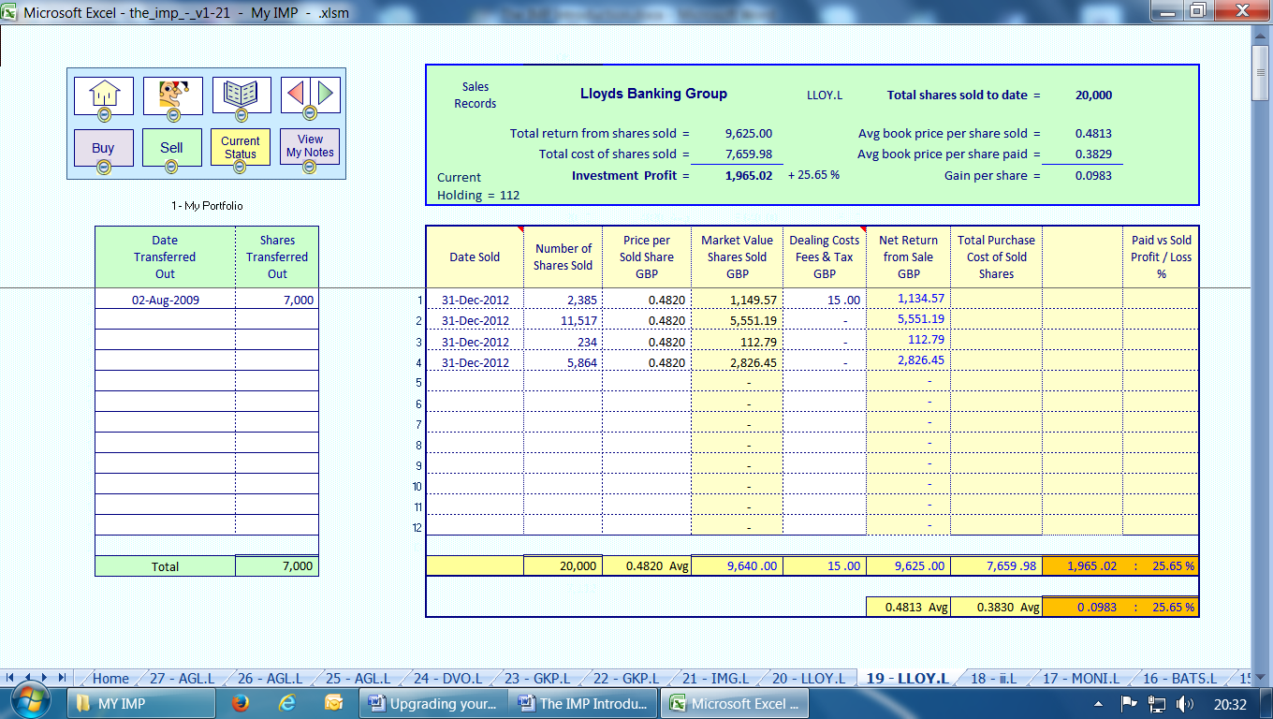
Clicking the Current Status button will display the Investment Summary Card.
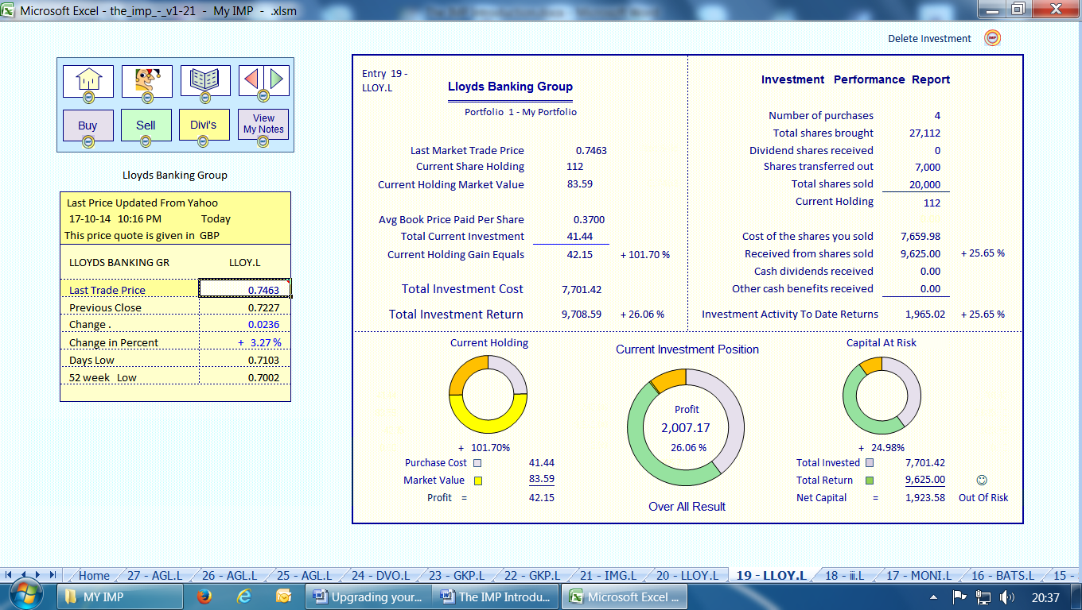

Screen Shots ... page 4 Taken from version v1-21
A typical investment card showing a closed position.
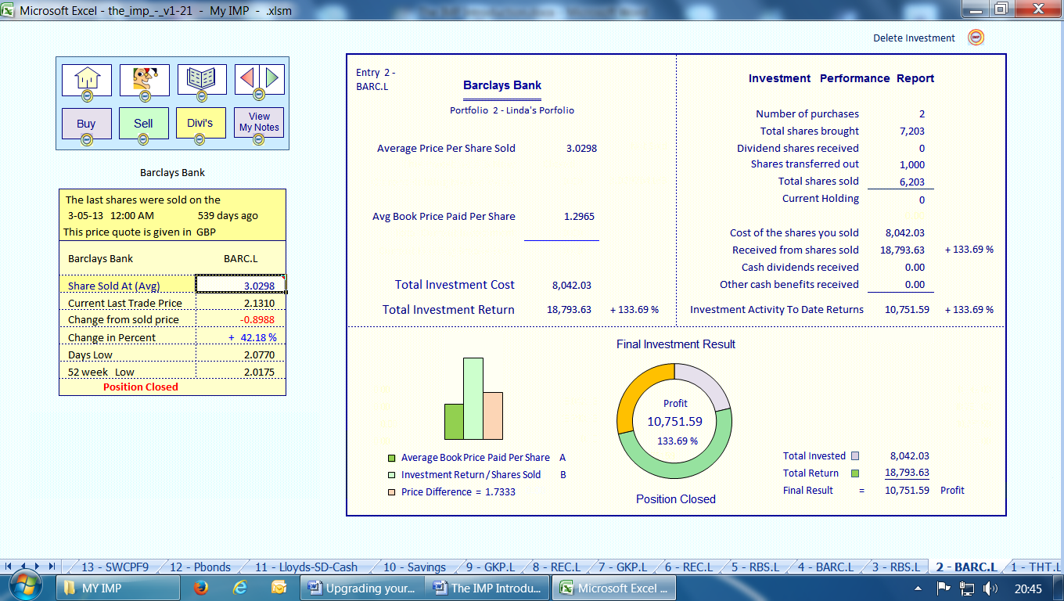
Eventually when you have a number of investments and assets entered together with any associated transactions, your Home page Current Holdings view should look something like this.
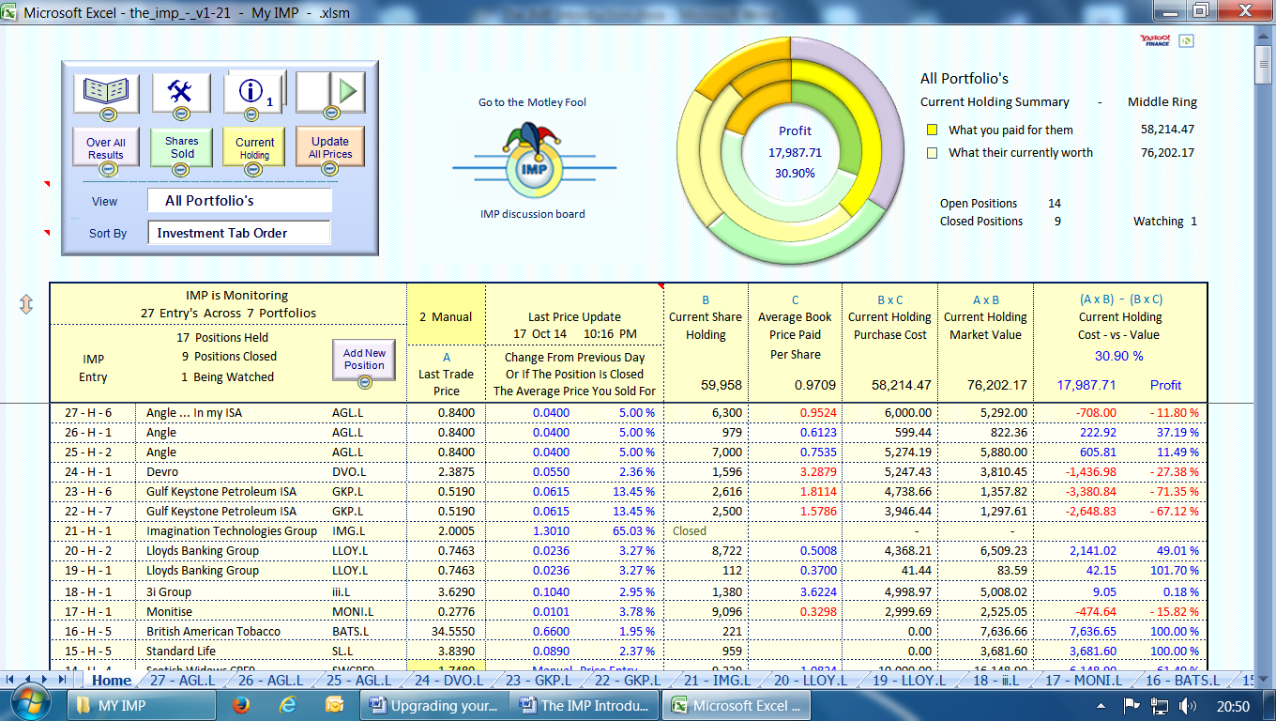
Screen Shots ... page 5 Taken from version v1-21
Clicking the green Shares Sold button would produce a view similar to this.
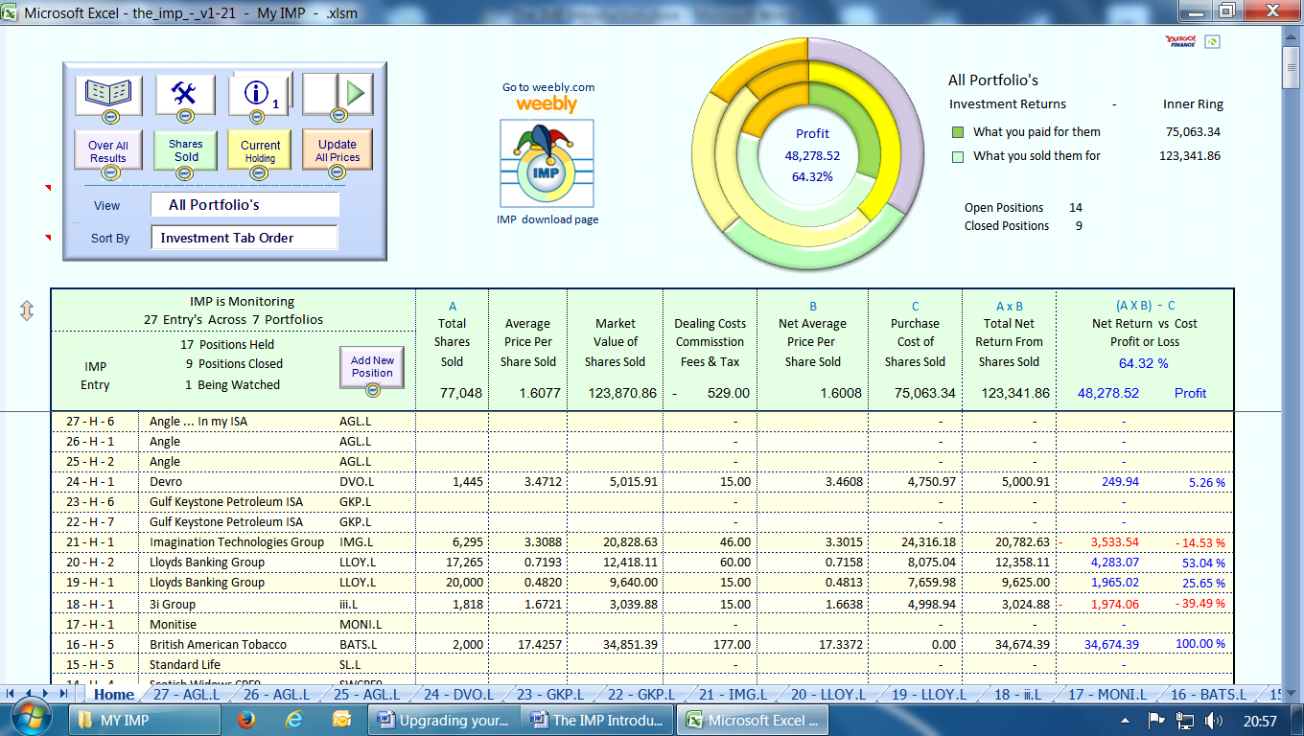

Clicking the purple Over All Results button would produce a view something like this.
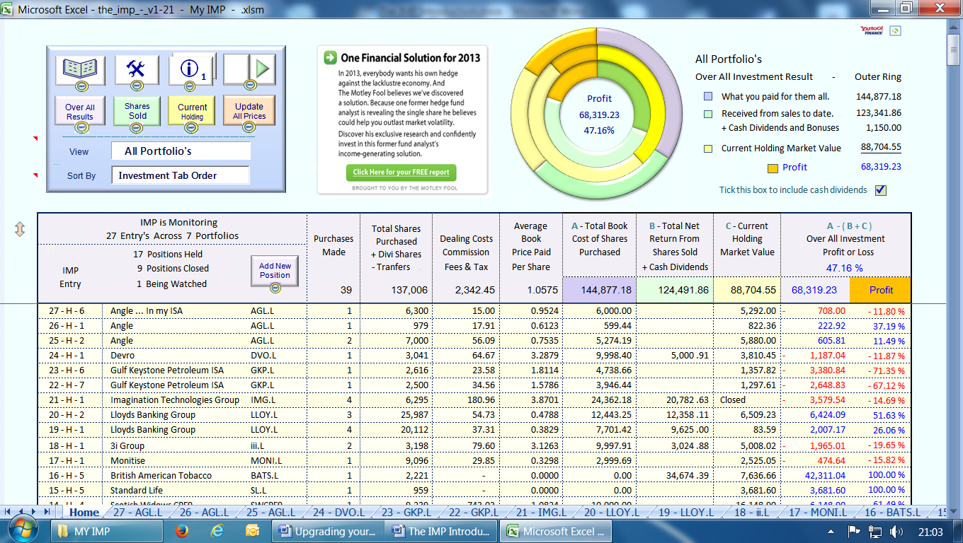

Screen Shots ... page 6 Taken from version v1-21
A detailed look at the Home page Three Ring Graphic.
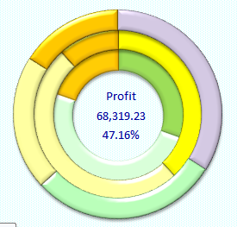
Each of the three rings represents the totals from the three views available.
They are as follows ...
Inner Ring = Shares Sold. Dark Green = What you paid for them.
Pale Green = What you sold them for.
Gold or Red = Profit or Loss.
Center Ring = Current Holdings Bright Yellow = What you paid for them
Pale Yellow = What there currently worth.
Gold or Red = Profit or Loss.
Outer Ring = Over All Result Purple = What you have paid out in total.
The Cost of your current holding plus the cost of the shares you have sold.
Green = Your total return to date.
The pale green figure from above
Yellow = Current market value of your holdings.
The pale yellow figure from above
Gold or Red = Profit or Loss.
Purple minus (Green plus Yellow)

